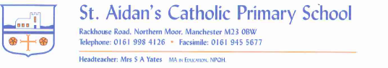

13th November 2020

Dear Parents and Carers,
Many thanks for the donations towards the Poppy Appeal. You raised £130.64.
Short reports are being handed out today in an envelope. There is a letter enclosed asking if you would like a phone call. Please return this letter to school on Monday. There is also a data sheet enclosed. If you need to update your details and cannot access ARBOR you can fill in the sheet and we will update it for you.
After School Sport and Music. These activities will hopefully resume the week beginning the 7th December.
Lunch Boxes. Sweets are not to be brought in as part of your child’s lunch. Please also remember we are a nut free school. Many thanks for your support.

As we are still under restrictions please could you maintain your distance when on our site. Many thanks once again for wearing face coverings and supporting us to keep everyone safe.
The children have all settled well into the new half term. Although this will not be the same as other Christmas half terms in our school we will still ensure that the children enjoy this special time.
We will continue to prepare them through Advent for the wonderful season that is to come.
With prayers,

Sarah Yates
Headteacher

