

Friday 4th December 2020

Dear Parents and Carers,

Another week ends….

The children are preparing well during Advent and I know that they will enjoy the last week in school as we become more creative!

Here is the Wednesday Word Link for the 2nd Sunday of Advent

<https://www.paperturn-view.com/uk/wednesday-word/hope?pid=MTA101634&v=12.3>

**Please could you make sure that when you are parking outside our school that you do not pull up on the pavement. The children are our priority and the pavement is for them. We could have an accident particularly during the Winter mornings and evenings. Please take great care.**

Thanks once again for keeping our school as safe as we can by wearing your face coverings and moving swiftly around our site.

Many thanks for your support and kind words during these difficult times.

With prayers,

Sarah Yates Head Teacher

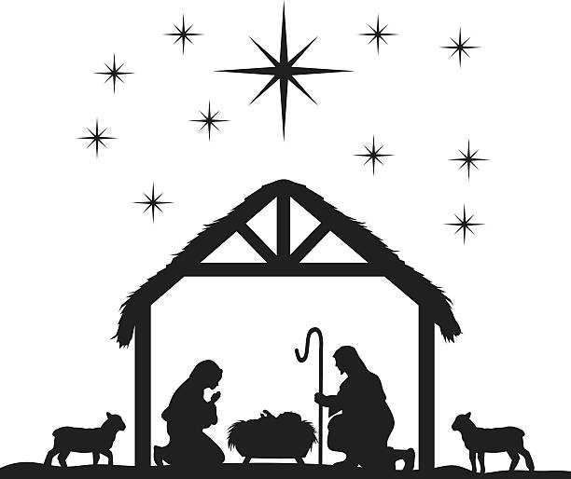

We wait in joyful hope