School closure work:

RE
Our topic for this half term is ‘New Life’. It’s very easy for the children to think of Easter as being a time of receiving lots of chocolate eggs from the Easter bunny but we would encourage you to explain the true meaning behind receiving eggs – they are a sign of new life. The children should be familiar with the Easter story and begin to understand that Jesus rose from the dead for us and went back to his Father in heaven. Even though Jesus is in heaven, he is always with us and can hear our prayers. If the children have any worries, they can share them with Jesus and he will listen. Please pray together every day, encouraging the children to sing/say the Our Father. This is the one we sing in class:
https://www.youtube.com/watch?v=HnUs5s33iqw
Perhaps the children could create a special ‘prayer area’ in their bedrooms or somewhere else in the house. It can be a place where they have ‘quiet time’ to pray for those in need.
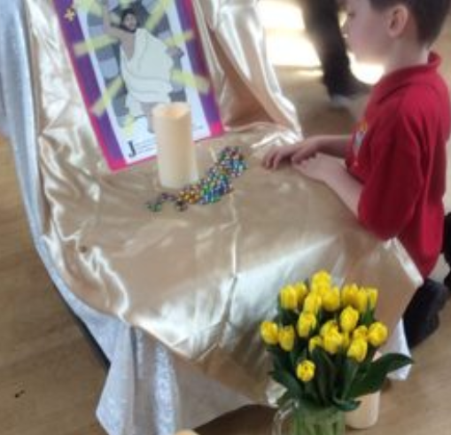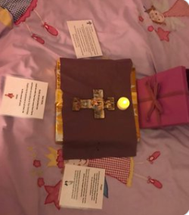

Here is another song we sing that is all about the special gifts God has given us:
https://www.youtube.com/watch?v=n3iG1gkW9R0

Literacy/Phonics
Please continue to practise reading and writing the set 1/2 sounds daily – please use the sounds we sent home on the treasury tags or the orange phonics book. Also, practise reading the tricky words. We can’t stress how important this is and the positive impact this learning will have on the children’s reading and writing. Remember that Ruth Miskin has a daily phonics lesson on YouTube and follows the same format of teaching as we do in class: https://www.ruthmiskin.com/en/find-out-more/help-during-school-closure/
Fun phonics games can be found here:
https://www.phonicsplay.co.uk/
https://www.topmarks.co.uk/english-games/5-7-years/letters-and-sounds
https://www.bbc.co.uk/cbeebies/shows/alphablocks

Here is an Easter tricky word activity booklet for the children to have a go at:
https://www.twinkl.co.uk/resource/easter-phase-3-tricky-word-activity-booklet-t-l-527557

Remember to practise reading every day. Here are some reading strategies to help the children learn how to read:

- Use Freddie fingers and your blending hand to sound out/decode words.
- Look at the first sound of the word.
- Use pictures for clues.
- Read the whole sentence and think what would make sense.
- Chop longer words up and sound blend both parts then put it back together. E.g playing – p-l-ay is ‘play’… i-ng is ‘ing’ so play and ing makes ‘playing’.

Top tips for reading at home:
- Read 10 minutes every night with your child.
- Discuss the illustrations – what is going on? Why?
- Predict what might happen next.
- Make up an alternative ending.
- Discuss what your child likes/dislikes about the text.
- Is the story fiction or non-fiction? How do we know?
- Can you change your voice for each character?
- Be guided by your child’s interests – read your own story books as well as school books.
- Sequence the events in the story. What happened at the beginning/middle/end?
- Read different types of texts – fact, fiction, poems, rhymes, picture books.

Here are 100 recommended reads for reception:
file:///C:/Users/Louisa%20Bolton/Downloads/Reception%20100%20books%20A4%20OneEd%20AW.pdf
Maths
- Practise counting up to and back from 20.
- Order numbers to 20 – maybe you could write these out for the children and jumble the numbers up for the children to order. Feel free to adapt this activity accordingly depending on your child’s ability.
- Find out which numbers when added together make 10 – get 10 objects and split them in different ways – can you write a number sentence to match? E.g 6 + 4 = 10.
- Look for 2D/3D shapes in the house – can the children say the name of the shape and describe its properties – E.g rectangle – is has 4 straight sides, 4 corners, 2 long sides and 2 short sides.
- Explore patterns – can you find any patterns around your house or in the garden? Can you describe the pattern? Can you draw your own pattern or make one using different objects?

Here are some useful links to the fun maths activities White Rose offers:
https://whiterosemaths.com/homelearning/easter-fun/
https://whiterosemaths.com/homelearning/early-years/

PE
Have you tried P.E with Joe Wicks at 9am every week day? This is a fun workout and something the whole family can join in with. Oti Mabuse (from Strictly Come Dancing) also has a dance class every day at 11.30 on YouTube for all the family to have a go at.
Cosmic kids yoga on You Tube is also really good. There are lots of fun videos to practice stretching, balancing, and relaxation. Give them a go on the following link:
https://www.youtube.com/user/CosmicKidsYoga

Understanding the world
Activities to try at home:
https://www.stem.org.uk/resources/community/resource/258613/early-yearsreception-science-homeworks
https://www.bbc.co.uk/cbeebies/grownups/understanding-the-world
There are so many lovely activities you can do at home that you might not necessarily think of as learning but that will really help your child to learn about the world around them and will improve their skills. Baking, cooking, planting some seeds or flowers in the garden, spotting different insects and plants when you go out on your daily walk are all great things to do. Everyday activities such as helping to wash the pots, putting on their own clothes, and helping to tidy away their toys are also really helpful in improving independence and confidence.

Useful Links:
www.twinkl.co.uk/offer and enter the code UKTWINKLHELPS
www.purplemash.com
https://www.educationcity.com/

(Remember your child’s log in details were sent home on the last week)

Finally, if you haven’t signed in to classdojo yet, please do so as this is what we will use to communicate with parents on a daily basis. We have loved seeing what the children have been up to at home so thank you to the parents who have shared those photos on Tapestry. Please continue to upload any photos of the children’s learning at home as they will be added to their online learning journeys and we really do love to see the fun the children have been having during this time.

Children, we are missing you so so much! Remember to be good for your parents and show off all the amazing learning you have done in school so far. Keep working hard but remember to have fun at the same time. We are so proud of all your achievements and can’t wait to see you all again.
Take care,
Mrs Bolton and Mrs Locker

